Guided Lecture Notes
Part I
LINK Activity  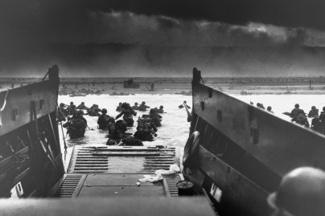 |  | What do you know about World War II?
At the Beginning: America, Germany, and Japan in the 1930s | America  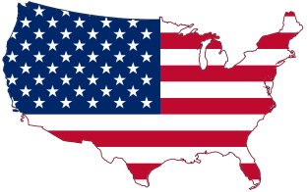 |  |  |  | Germany  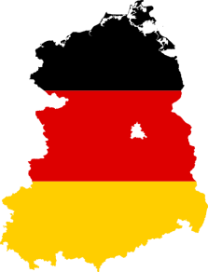 |  | Japan  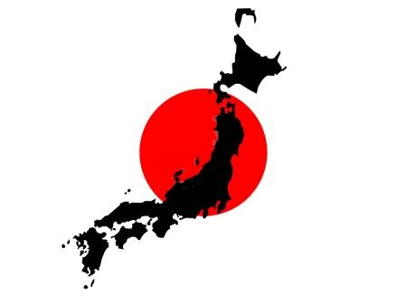
List the major events and people present within the respective regions during the 1930s
Define each term in your own words. | Isolationism |  |  |  | Fascism  Anschluss  Lebensraum
Japan’s New Order  “What Japan seeks is the establishment of a new order which will insure the permanent stability of East Asia. In this lies the ultimate purpose of our present military campaign...What Japan desires of China is that that country will share in the task of bringing about this new order in East Asia. She confidently expects that the people of China will fully comprehend her true intentions and that they will respond to the call of Japan for their co-operation." (1938) |  |  |  | What are Japan’s real desires? How do these words contradict their military actions? (Bullet point your answers, you will share them with a partner.)
Avoiding War  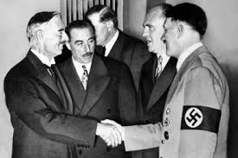  Define Appeasement:  Why was Europe so quick to allow Hitler to annex Austria and the Sudetenland? |  |  |  | In 1938, Germany annexed ________ and ____________. This placed both areas under the complete control of the Nazi government. On September 15, ___________ ____________ met Hitler at Berchtesgaden. He pledged to give Germany all the areas within Czechoslovakia that had a German population of more than_________ percent. __________ was persuaded to agree. Hitler then altered his criteria, demanding all of the ____________. At the __________ Conference on September 30th, Britain and France agreed to his demands. Chamberlain was confident that he had secured “_______________________.”  What statement is the political cartoon making about appeasement? Do you agree with it?  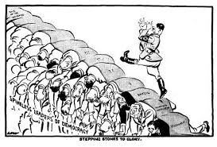
War Comes to Europe  List the Allied and Axis Powers.  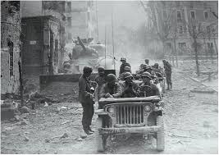  (We will go over them in the next slide, add those that you are missing, along with their major leaders.) |  |  | Allied Powers |  |  | Axis Powers
War Comes to Asia  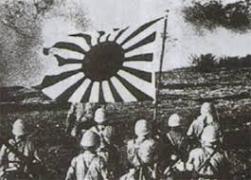 |  |  | Why did Japan choose to invade China? Are there any similarities between Germany and Japan’s motivations?
Remaining Neutral  Create a brief timeline of America’s gradual move from complete neutrality and isolationism to an interventionist policy. Begin with the 1930s Neutrality Acts and define each policy. (Work with your group.)  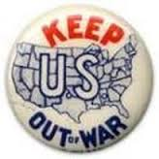 |  |  | 1930s  1939  1940  1941  How is FDR convincing the US people to support Europe? How is America an "Arsenal of Democracy?" Would you agree to lend support in the form of money, ships, and weapons?
Pearl Harbor  “A date which will live in infamy.”  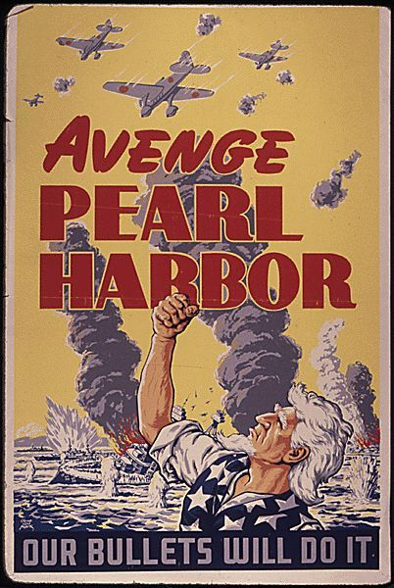 |  |  | What were Japan’s motivations for attacking Pearl Harbor? (Jot down a few ideas. We will discuss as a class.)

Part II
For each battle, summarize what occurred in your own words. Include which countries were involved, which side was victorious, and the importance/significance.
European Theater | Pacific Theater
Normandy (D-Day/Operation Overlord) | Battle of the Coral Sea
Battle of the Bulge | Battle of Midway
 | Battle of Iwo Jima
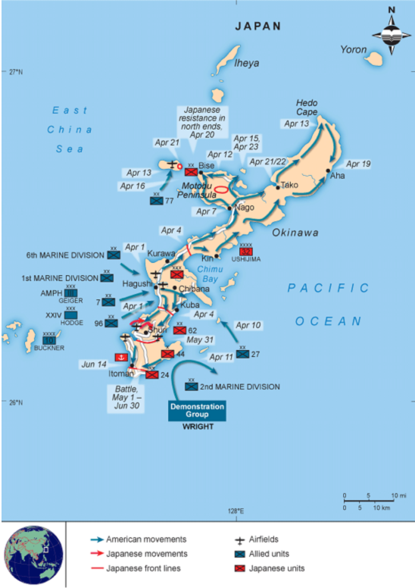 | Battle of Okinawa  After watching the clip on the invasion of Okinawa, what is your reaction? Is that what you were expecting in terms of fighting?
How did American participation in the European theater change the war? What are some examples? | How was the Pacific Theater different from the European Theater?

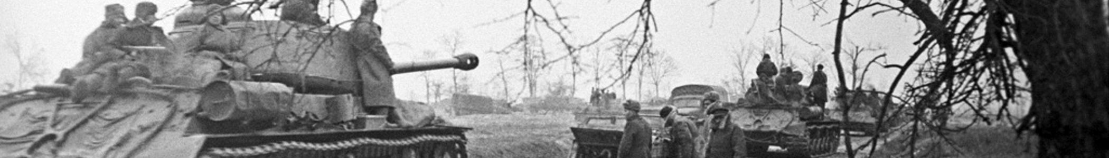
Final Question: Did the United States realistically have any option other than full participation in World War II? What could have potentially happened had the US maintained its isolationist policies of the early 1930s?

